|  |
| --- |
| *Dear Candidate,*  *It’s our pleasure to invite you to perform a test set given below. Please use any IDE at your choice. The source code result (including photos, assets, etc.) should be zipped and return to our Technical Recruiter via email.*  *Though we do not limit the timing, we estimate that it may take you 4 hours to complete the task.*  *Thank you and we look forward to review the result!* |

# Html Design Task

**Modify index.html so that it reflects the given design.**

Task description

A small digital agency asked you to create a landing page for them (image in the next page). They have sent over a design, all graphical assets and content of the page. Your task is to modify index.html (you can add extra files if needed) so that it reflects the given design. The details are specified below:

Your solution should:

* Be written in HTML5
* Be compressed in a .zip file containing the index.html file

Your solution does not have to be pixel-perfect.

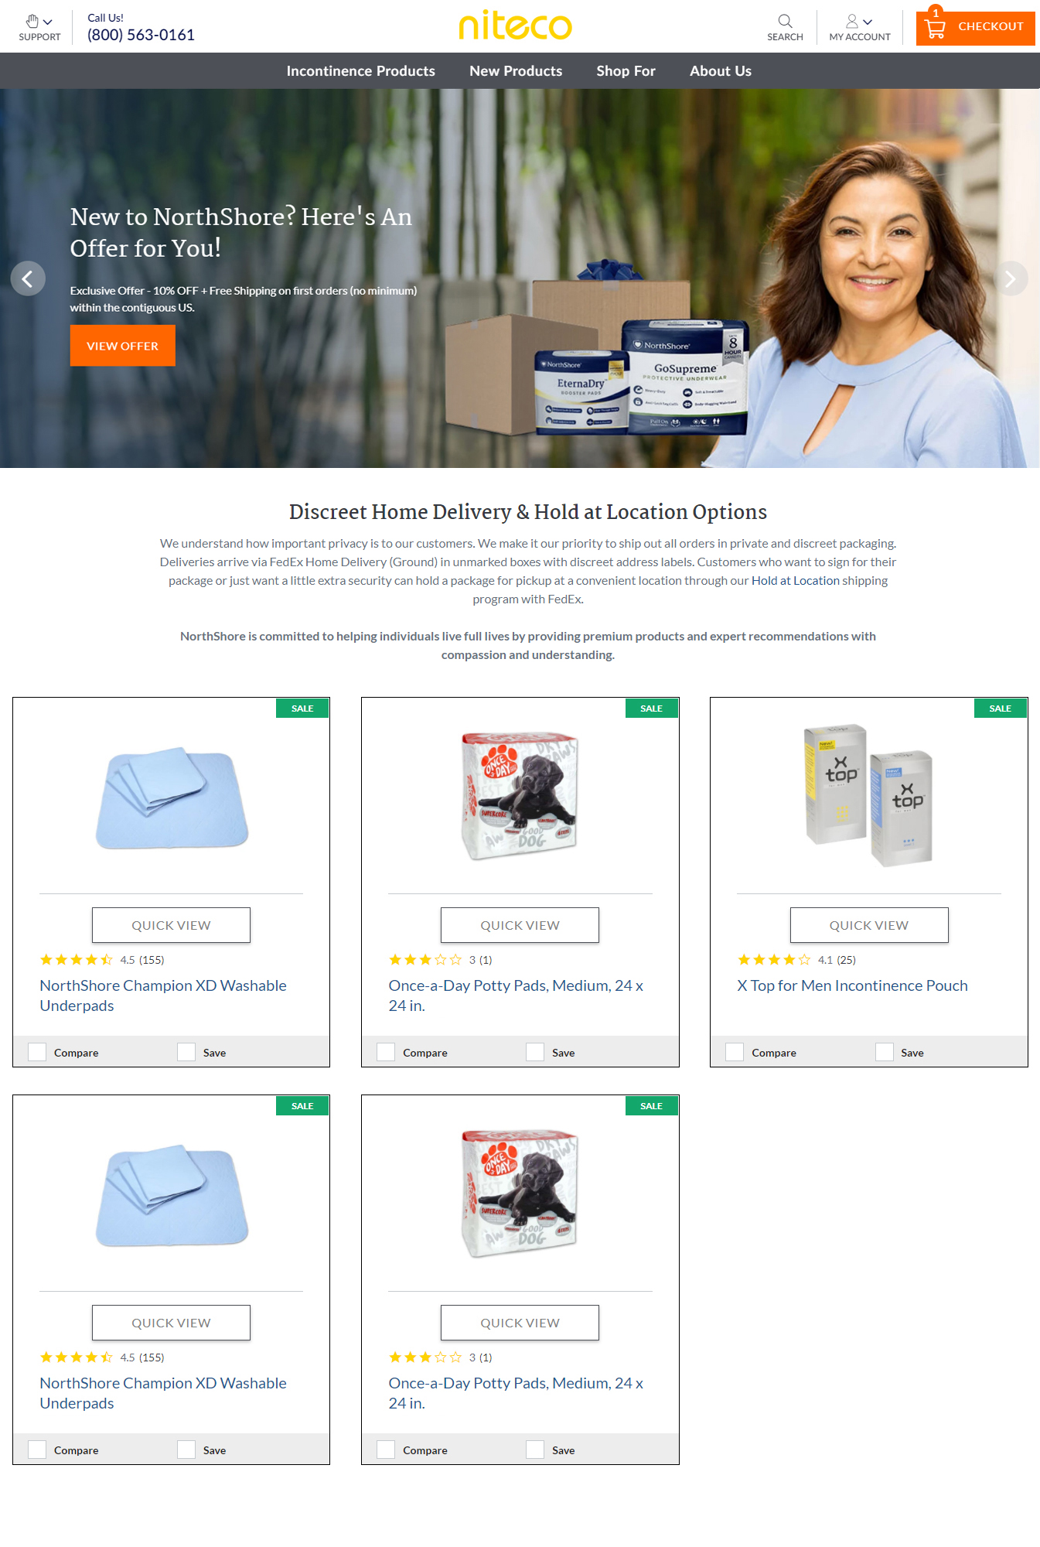

# Task

* Sử dụng html5/css3
* Sử dụng javascript (hoặc frameworks ưu thích nhất)
* Css sử dụng CSS Preprocessing
* Responsive
* Performent

*------------------------------------End of the assignment------------------------------------*